**TUGAS IMPAL KEL 4**

Nama kelompok (IF40-01):

-Crisnandra Rahmita Mardiantien(1301160103)

-Mochammad Aria Putra Suwantra(1301160200)

-Gary andersen(1301164540)

-Dinda Mareta Putriany (1301164558)

1. **Menentukan class diagram yang terdapat methode terbanyak**

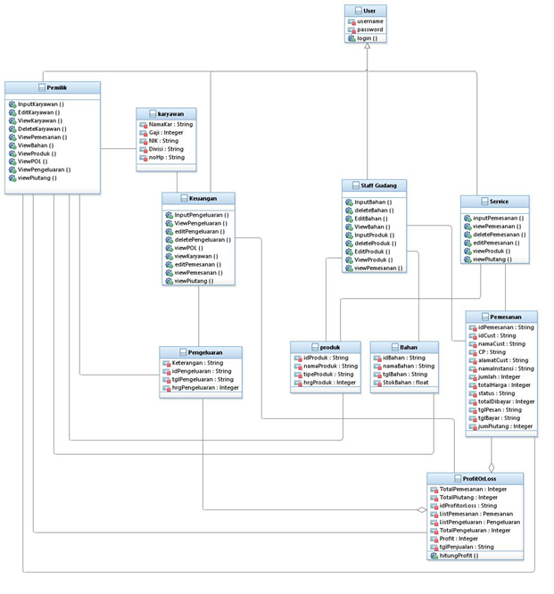

Class pemilik memiliki methode terbanyak dengan 10 method

1. **Cyclomatic complexity setiap Methode**

a. flowchart

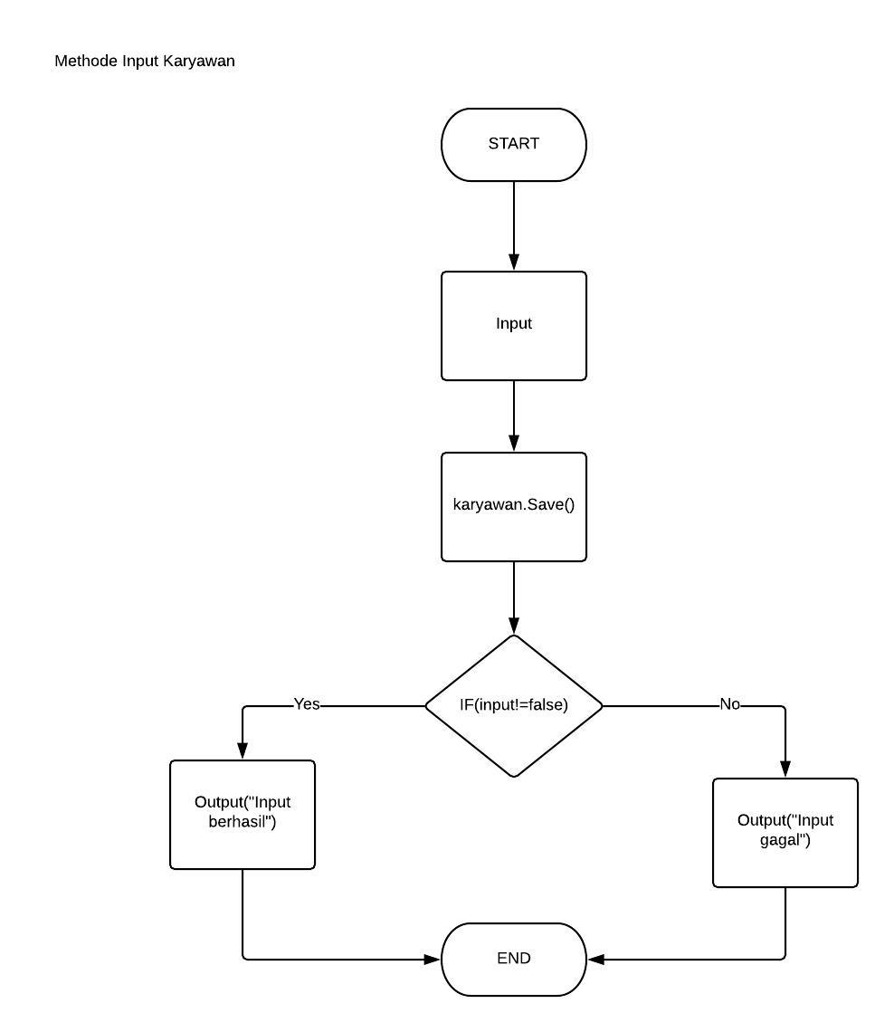

Cyclomatic complexity= 1+1 = 2

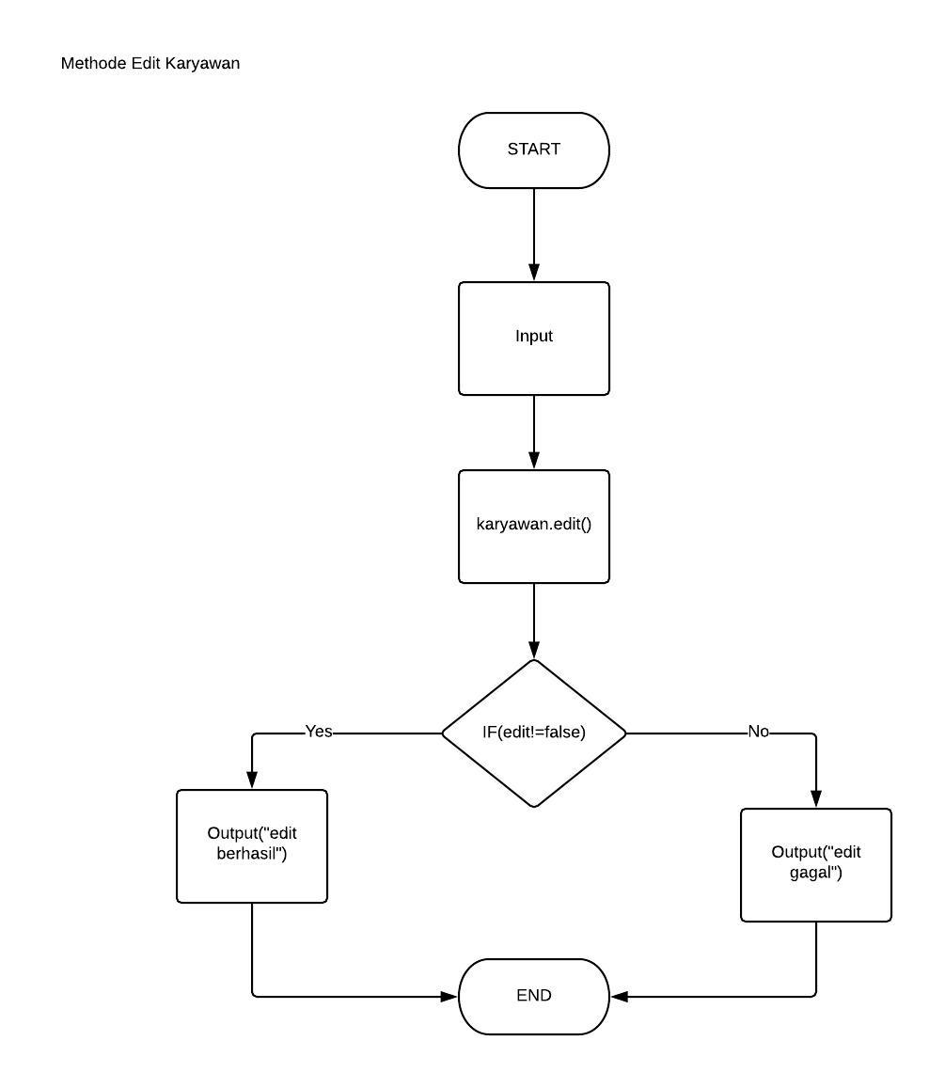

Cyclomatic complexity= 1+1 = 2

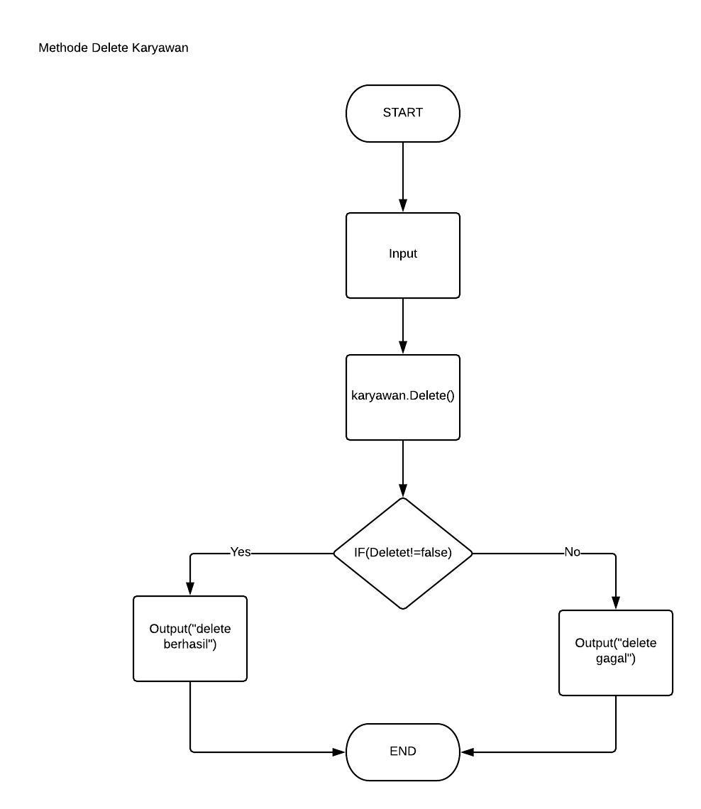

Cyclomatic complexity= 1+1 = 2

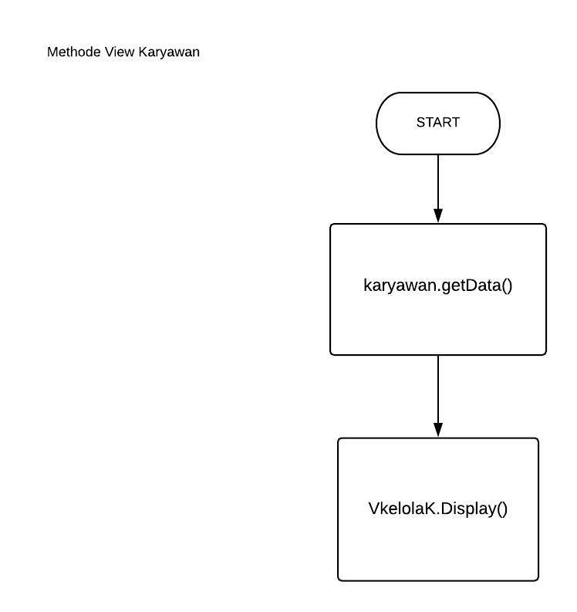

Cyclomatic complexity= 0+1 = 1

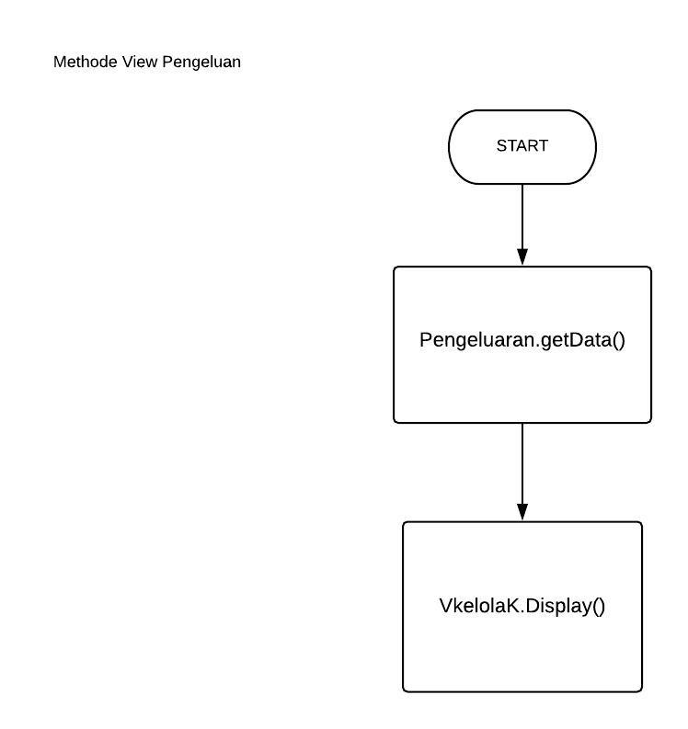

Cyclomatic complexity= 0+1 = 1

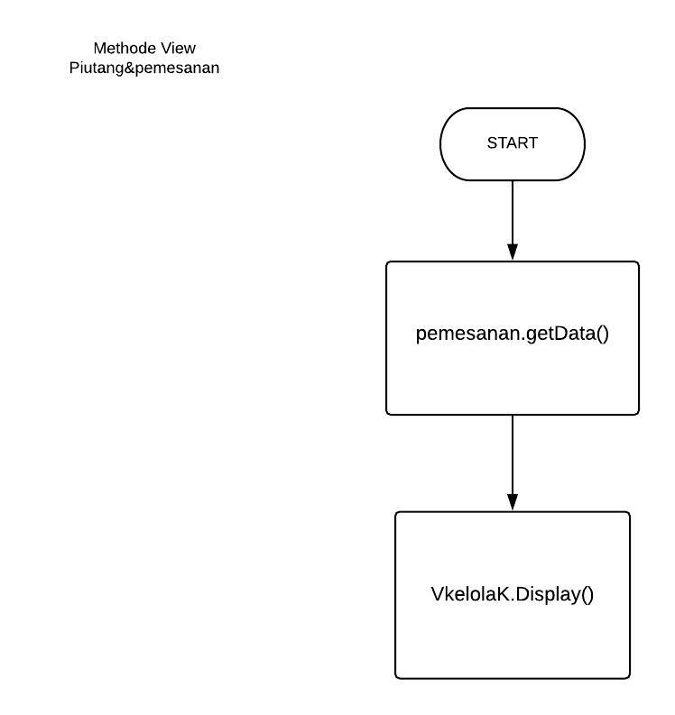

Cyclomatic complexity= 0+1 = 1

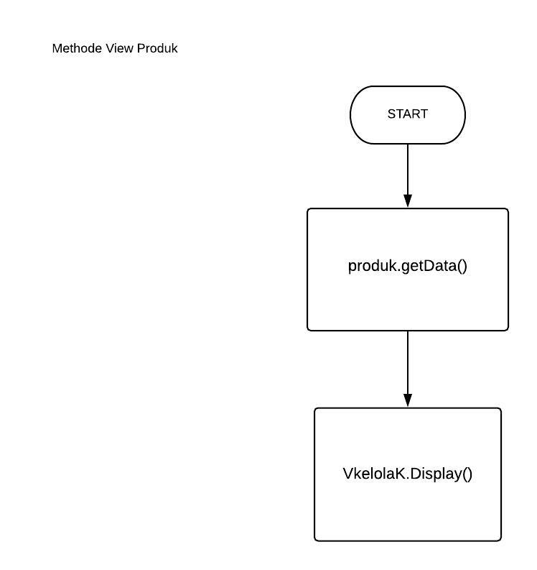

Cyclomatic complexity= 0+1 = 1

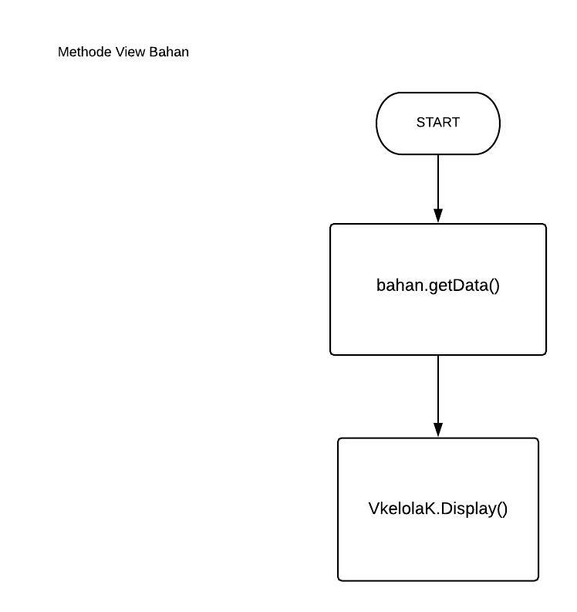

Cyclomatic complexity= 0+1 = 1

\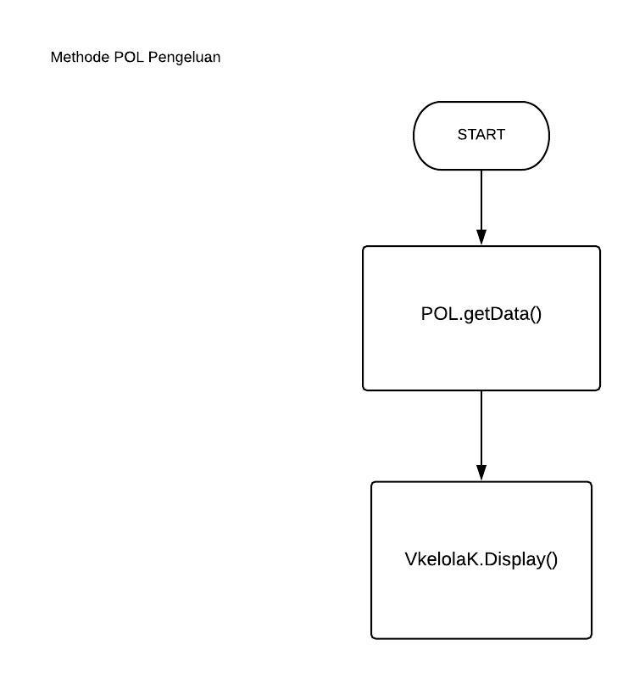

Cyclomatic complexity= 0+1 = 1

1. **Test Case Setiap Method**

*Lintasan cyclomatic:*

-Methode Input Karyawan

Lintasan 1= Input->Karyawan.save()->IF(insert!=false)->Output Berhasil

Lintasan 2= Input-> Karyawan.save()->IF(insert!=false)->Output Gagal

-Methode Edit Karyawan

Lintasan 1=Input->karyawan.edit()->IF(edit!=false)->Output Berhasil

Lintasan 2=Input->karyawan.edit()->IF(edit!=false)->Output Gagal

-Methode delete karyawan

Lintasan 1=Input->karyawan.delete()->IF(edit!=false)->Output Berhasil

Lintasan 2=Input->karyawan.delete()->IF(edit!=false)->Output Gagal

|  |  |  |
| --- | --- | --- |
| Nama Method | Input | Output |
| Input karyawan | NULL | Input gagal |
| Edit karyawan | 123,bayu,keuangan,1000000,0813978926 | edit Berhasil |
| Delete karyawan | 123,bayu,keuangan,1000000,0813978926 | Delete berhasil |